Unit One
Geography: Its Nature and Perspectives
- Geography is the study of where things are found on Earth’s surface and the reasons for the locations.
- Human Geography the study of human activities from a spatial context and asks two simple questions:
  - Where are people and activities found on Earth?
  - Why are they found there?
- Basic Ideas of Geography
  - All places have location, direction, and distance with respect to other places
  - Places may be large or small; the scale is important
  - Places have both physical structure and cultural content
  - The characteristics of places develop and change over time
  - The elements of places interact with other places
  - The content of a place is rationally organized
  - Places may be classified into regions with similarities and differences
- Location position on the Earth’s surface.
  - Absolute Location
    - The exact position of a place
    - Latitude and longitude - used to describe a point on earth in reference to degrees, minutes, and seconds
  - Relative Location
    - The position of a place in relation to the position of another place
    - Conveys interconnection and interdependence between different places
  - Site
    - Describes the physical and cultural characteristics of a location
  - Situation
    - Describes where a location is in reference to surrounding features in the larger region
  - Scale (Map-scale)
    - Relationship between the size of a feature as depicted on a map and the size of the feature in actuality
- Maps and Map Types
  - A map is a two-dimensional or flat-scale model of Earth’s surface.
    - Cartography is the science of mapmaking.
    - Maps serve two purposes…
      - As a reference tool to identify an object’s absolute and relative location.
      - As a communications tool to convey the distribution of human activities or physical features.
    - Thematic Map represents a single variable over an area (tells a story)
    - Mental Map an image in one’s mind about an area, location, or environment
    - General Purpose/Reference Maps display a variety of variables in an area
the study of human activities from a spatial context

Using examples, explain differences between early maps and contemporary maps to illustrate how we communicate far more complex geographic data than earlier maps.

  - Earliest maps were reference tools—simple navigation devices to show a traveler how to get from Point A to Point B.
    - First world map prepared by Eratosthenes (276–194 B.C.)
  - Contemporary mapmaking - Shifted from simply being a tool that provides location reference to a tool used by geographers to communicate complex geographic phenomena.
Label the maps correctly: Dot, Choropleth, Isoline, Symbol

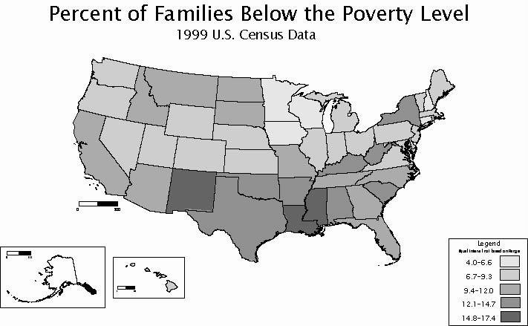 | 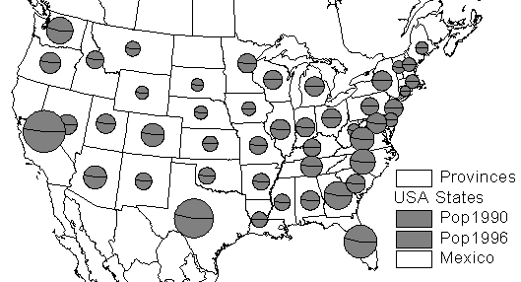
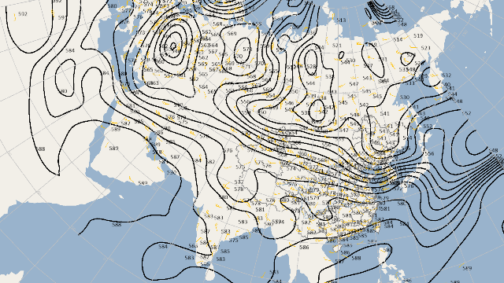 | 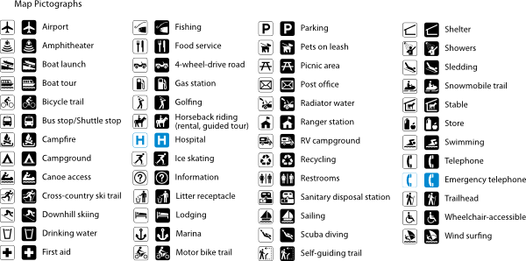

Three Types of Map-scale are: | Define projection: | Define Meridians:
Define International Date Line: | Define Greenwich Mean Time: | Define Parallels:
Define GIS: | Define GPS: | Define Remote Sensing:
- Regions are unique areas with unifying characteristics
  - Formal an area that can be identified by its homogeneous cultural or physical characteristics
  - Functional an area in which there is a center from which social or economic activities spread
  - Vernacular an area not defined by any set of physical data, but by human conception of the area

Region Type | Also known as… | Common Associated Traits | Example of a big-sized… | Example of a small-sized…
Formal |  |  | The U.S.A | A zip code region
Functional |  | Has a clearly defined center of activities.  Affected by distance decay!
Vernacular | Also known as a perceptual region.
Which region types are most, and least, influenced by the process of space-time compression and why?
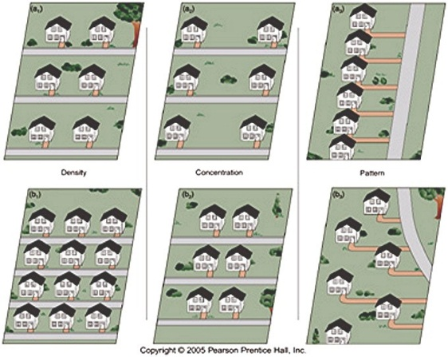
- Place is a specific point on Earth distinguished by a particular characteristic.
- Space refers to the physical gap or interval between two objects.
- The arrangement of objects in space is known as its distribution.
- Geographers identify three main properties of distribution across Earth.
  - Density- frequency with which something occurs in space.
    - It involves the number of a feature and the land area
  - Concentration- extent of a feature’s spread over space
    - Closely spaced together is known as clustered.
    - Relatively far apart is known as dispersed.
  - Pattern- geometric arrangement of objects in space
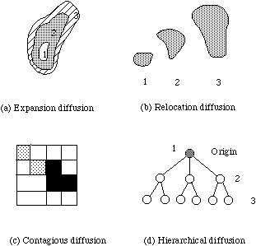
- Spatial Diffusion method by which cultural elements are spread
  - Expansion Diffusion the element spreads to other areas but remains strong in its hearth region
  - Contagious Diffusion the element spreads uniformly outward from its source region
  - Hierarchical Diffusion process of spreading the element through tiers and often occurs in urban areas
  - Relocation Diffusion element is physically and usually intentionally carried from one region to another as a result of migration
  - Stimulus Diffusion Spread of an underlying principle even though a characteristic itself apparently fails to diffuse. Example: Veggie burgers
  - Diffusion Barriers conditions that hinder either the flow of information or the movement of people
  - Acculturation adopting some or all of the characteristics of another dominant culture
  - Syncretism fusing old and new parts of culture together
- Cultural Change Theories
  - Environmental Determinism belief that the physical environment is solely responsible for shaping human actions and behaviors.
  - Possibilism belief that people, and not the environment, are the forces responsible for shaping culture.
- Economic Sectors
  - Primary Sector agricultural and extractive activities. Relied upon by many developing nations.
  - Secondary Sector processing activities – manufacturing, construction and power production. Many developing nations support secondary activities with lower labor costs than developed countries.
  - Tertiary Sector service activities. Many developed countries’ economies are dominated by tertiary sector jobs.
  - Quaternary Sector informational activities. The Quinary Sector is a new theoretical sector within the quaternary sector of high level management jobs.
- The 4 Traditions of Geography-American Perspectives
  - Spatial Tradition
    - Emphasis on movement and location
    - Deals with the shape of the land
  - Area Studies Tradition
    - Emphasis on region, place and history
    - Deals with physical and cultural characteristics
  - Man-Land Tradition
    - Emphasis on the relationship between external conditions and human actions
    - Overlaps with the Area Studies Tradition
  - Earth Science Tradition
    - Emphasis on geology
    - Deals with how physical systems affect humans (hydrological cycle, wind patterns, etc)
- Earth’s Physical Systems
  - Geographers classify natural resources as part of four interrelated symptoms.
    - Abiotic system is one composed of nonliving or inorganic matter.
      - Atmosphere: thin layer of gas surrounding Earth
      - Hydrosphere: all water on and near Earth’s surface
      - Lithosphere: Earth’s crust and layer just below the crust
    - Biotic system is one composed of living organisms.
      - Biosphere: all living organisms on Earth
      - Ecumene: area on earth where humans live

